Elizabeth Hawkins

CIS-245 Linux Administration

9/12/2021

System set up documentation for Ubuntu

Part-1

Ubuntu-64bit

The first step you must do is download your server. I am going to be using a Ubutu-64-bit server I am going to go on the website and download it from [www.Ubuntu.com](http://www.Ubuntu.com) I downloaded the Ubuntu-20.04.3 Server iso file.

Next you must create a virtual machine. I use the VMware Workstation Pro 16 to create my virtual machines. I use the typical(recommended) to create my virtual machine and then I click next.

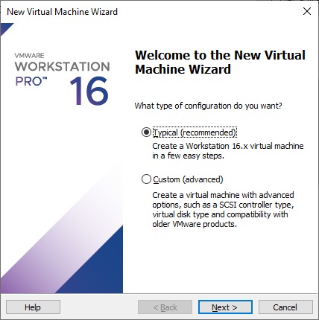

Next is the Guest Operating System Installation. You must browse through your computer and find the Ubuntu iso file that you downloaded and put it in the Installer disc image file (iso): Then I click next.

The next step is the Easy Install Information where you have to put your Full name, Username, Password, and to Confirm your password. Then I click next.

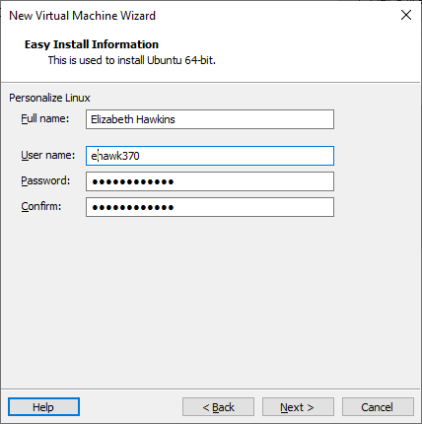

Next is the Name the Virtual Machine. You can name your Virtual Machine anything you want but, I am just going to keep the standard name Ubuntu-64 bit. The location is where your Virtual Machine will be stored then I click next.

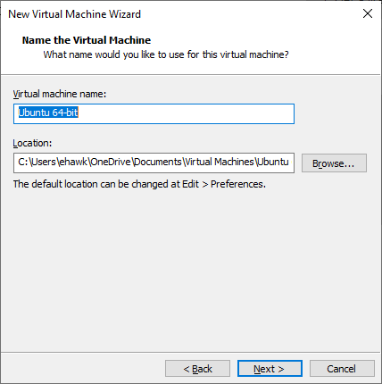

The next step is to Specify Disk Capacity which allows you to choose how much disk space you want your virtual machine to have. I used 20.0GB Maximum disk size. I selected the Split virtual disk into multiple files instead of single file because if you split the file it “makes it easier to move the Virtual Machine to another computer”. Then I click next.

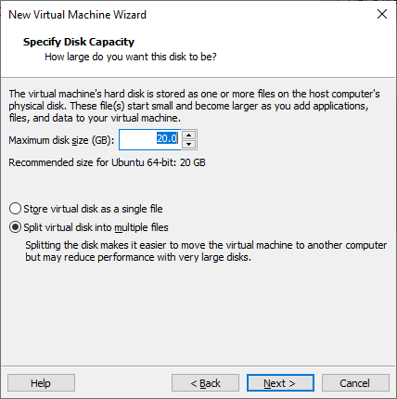

The next step will take you to the Ready to Create Virtual Machine. This means everything you setup is ready to go. If you want to make changes you can do so by choosing the Customize Hardware button. These setting will allow you to customize the setting of your Virtual Machine like increasing or decreasing the memory Ram or the Processors. I used 4392MB for the memory and 2 processors for my machine. When you’re done customizing your hardware hit the finish button.

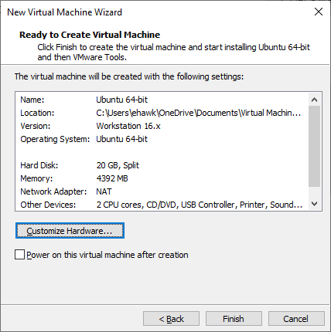

Next you power on your Virtual Machine and wait until it finishes booting up. Now this is going to take you through the steps to configure your Virtual Machine.

Step 1. Choosing your language: You must choose the language you want the setup to be in. Since I speak English that is the language I am going to choose. Press enter and follow the next step.

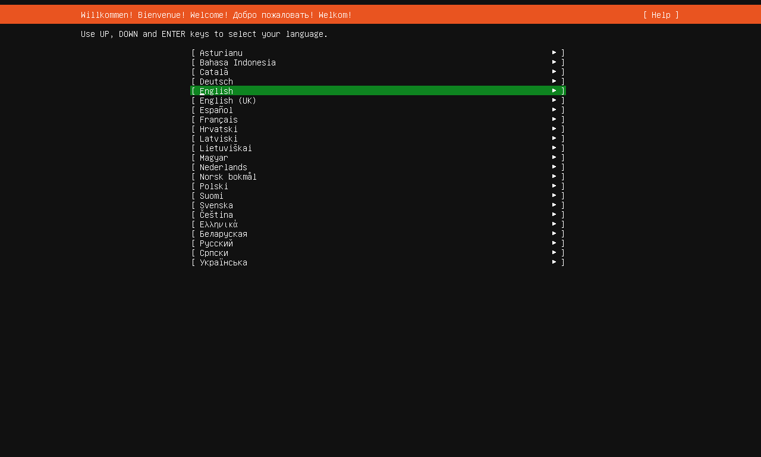

Step 2. Keyboard Configuration: With the keyboard configuration it allows you to choose the language you want your keyboard layout to be. I chose English and press done to continue to the next step.

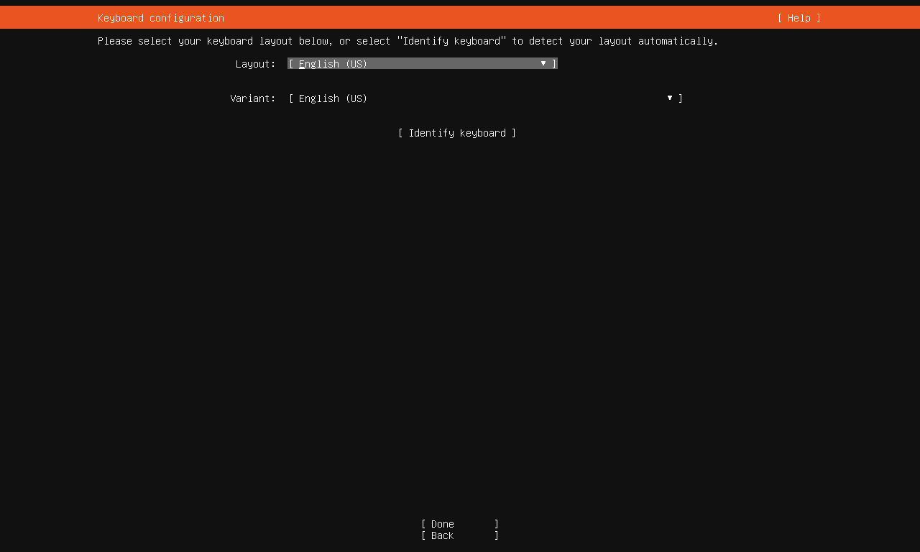

Step 3. Network Connections: In this step it will allow you to setup a network connection. You must make sure you have an internet connection because the connection is what allows you to communicate with other computers. After you establish that you have a connection press done and continue to the next step.

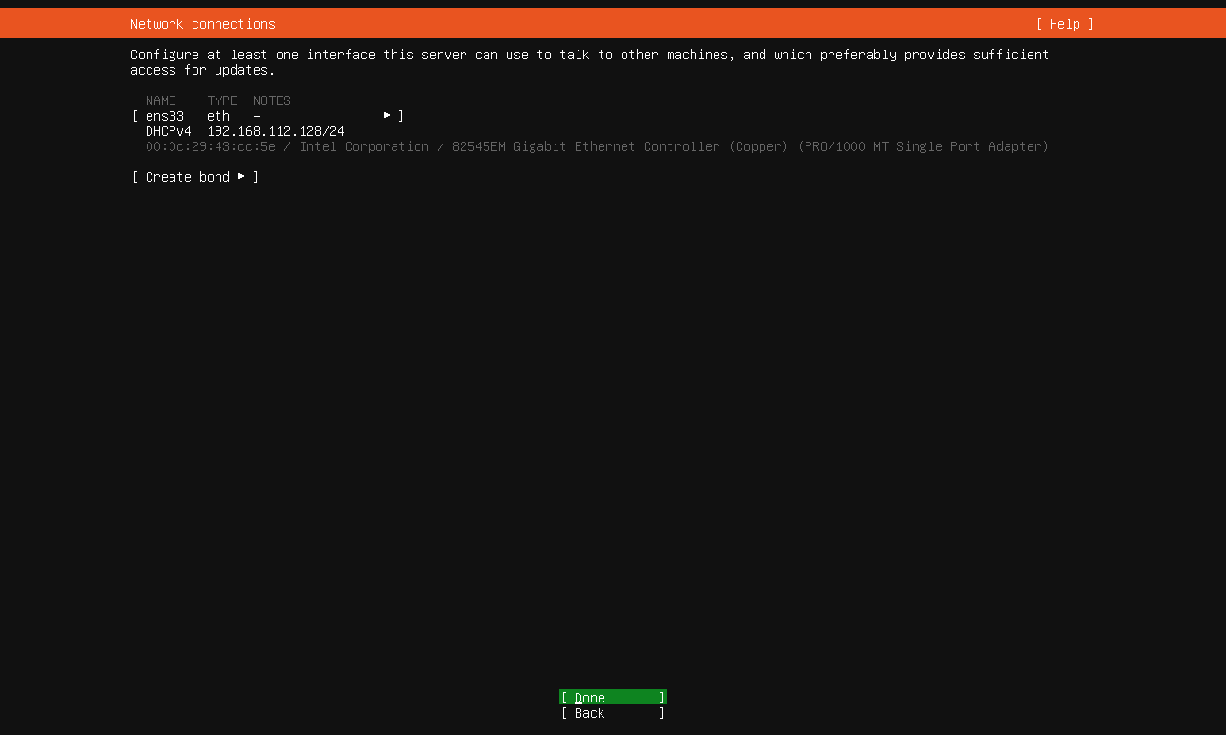

Step 4. Configuration Proxy: This step allows you to add a configuration proxy which allows you to speed up the transfer of information between the server and your computer. If you have one you can enter the proxy address if not you just press done and continue to the next step.

Step 5. Configure Ubuntu archive mirrors: In this step it allows you to configure Ubuntu archive mirrors. Ubuntu already has a default mirror so you can use that one. You can also choose another archive mirror if you do not want to use the default mirror. When you’re done choosing the archive mirror press done and continue to the next step.

Step 6. Guided storage Configuration: In this step it allows you to configure the storage layout by using the layout that is already there or customizing your own. For this we are going to use the entire disk space that we used when we created our Virtual Machine. Then continue to the next step.

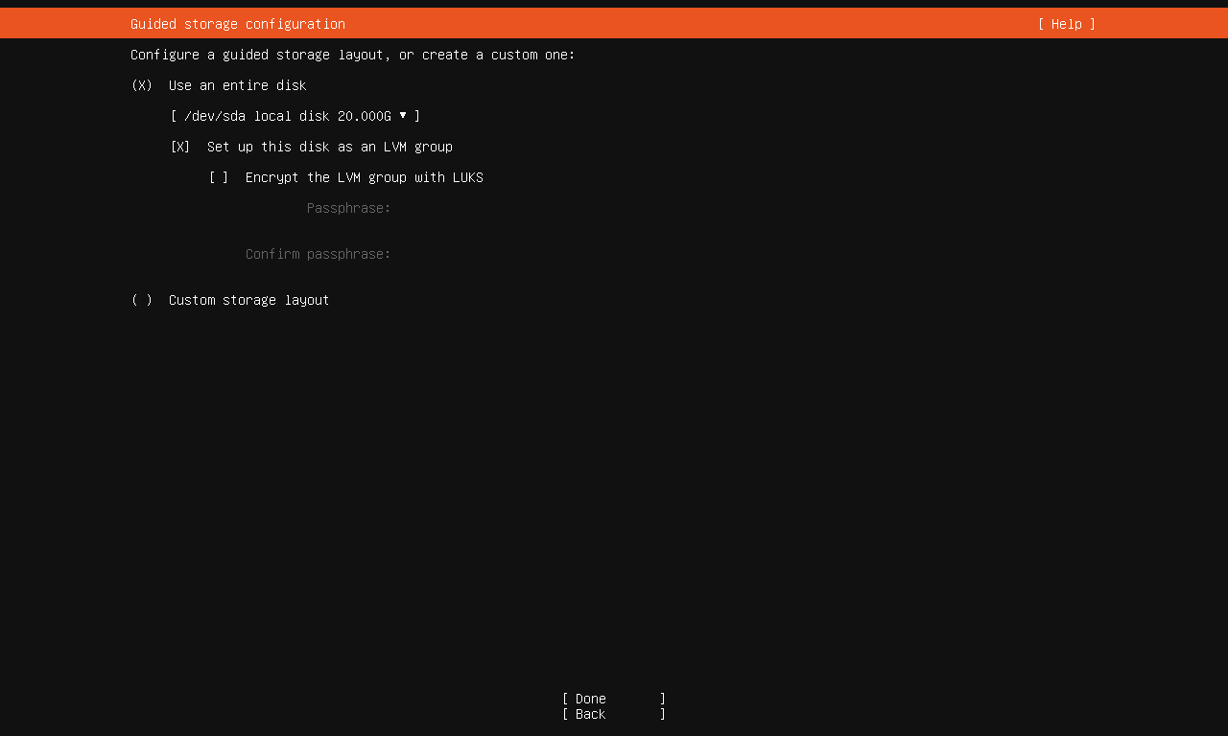

Step 7. Storage Configuration: In Storage Configuration this step will display the File System Summary, the Available Devices, and used Devices. Click done then continue to the next step.

When you click done it ask you if you want to continute and by doing so it will start the installation of your Ubutu Server. Click continue.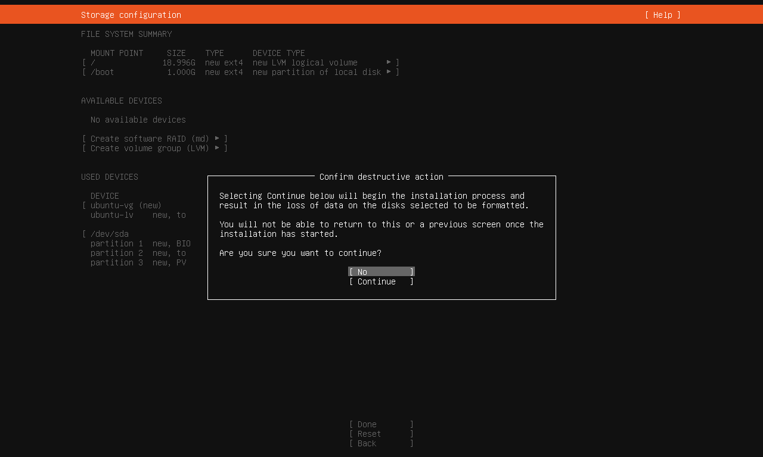

Step 8. Profile Setup: In the Profile Setup this allows you to create your profile by selecting your name, your servers name, picking a username, and create a password. After that you press done and move on to the next step.

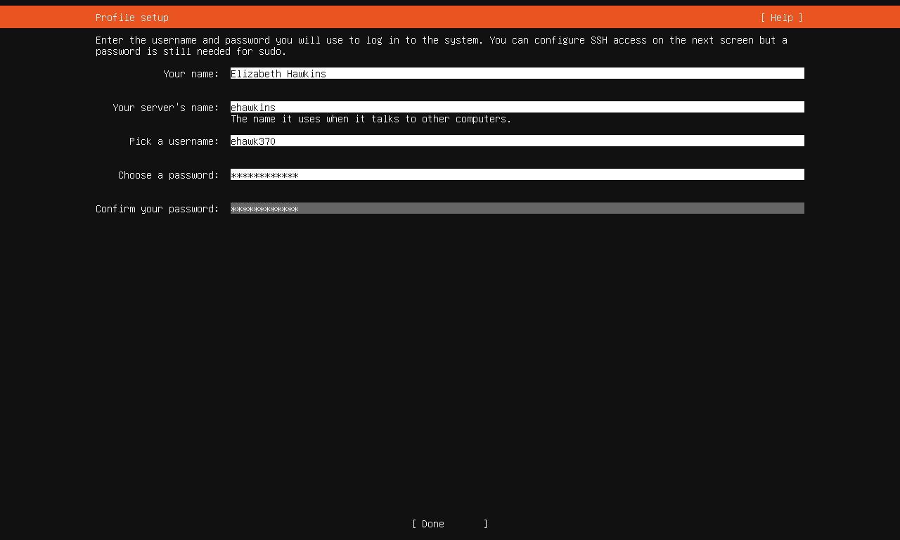

Step 9. SSH Setup: SSH Setup allows you to choose if you want to install an Open SSHserver package. You should always chose to have an OpenSSH because it enables you to have a secure remote access and allows transfer of data between networked computers. After click done and go on to the next step.

Step 10. Feature Server Snaps: Allows you to add any additional add-ons you want for your server. After you are done setting up the features click done and go on to the next step.

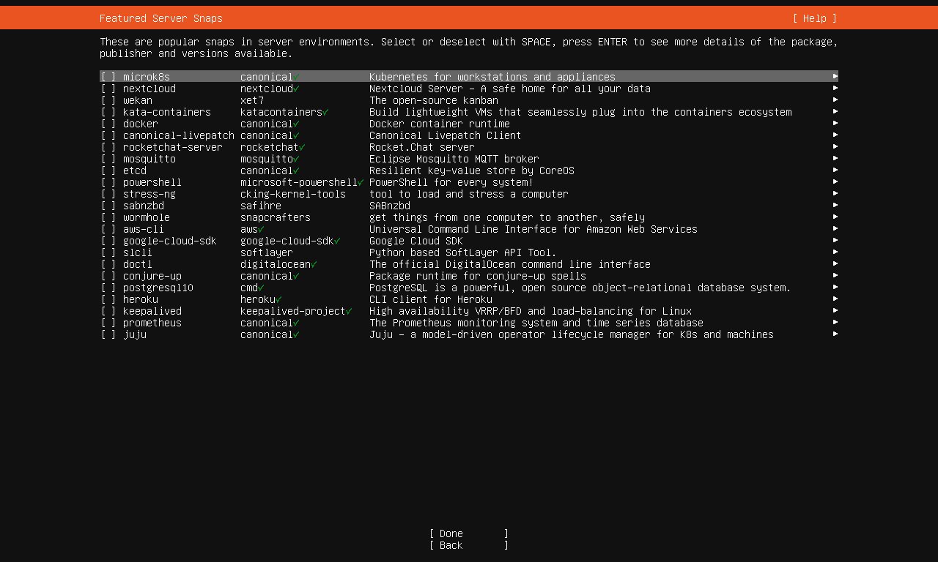

When you press done the installation will begin and all the setups you chose will be installed then you press done and then reboot.

This is what you see to confirm the installation is being installed.

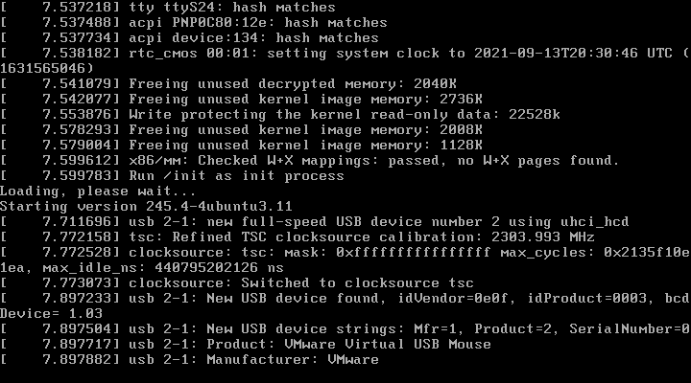

When the Ubuntu Server is finally finished downloading it will prompt you into the login screen where you will enter your login information and your password. These are the steps I used to download my Ubuntu Server.

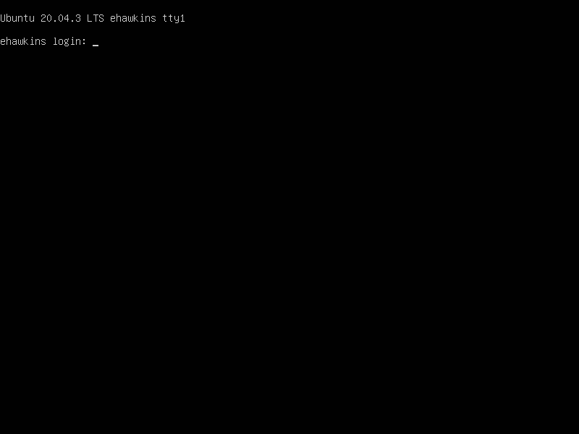

When it comes to file-sharing there are so many file-sharing options. I like to use PowerShell. You can get PowerShell on your Ubuntu server to do that you must install it from the command line.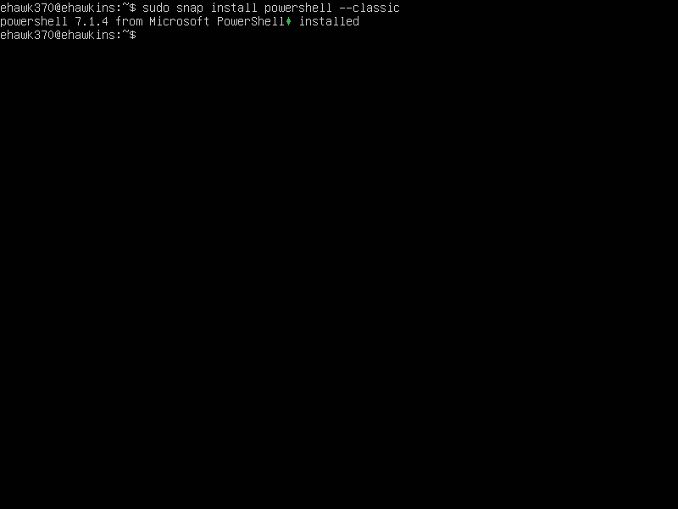

Once PowerShell is installed the only thing you need to do to connect to power shell is type the command pwsh.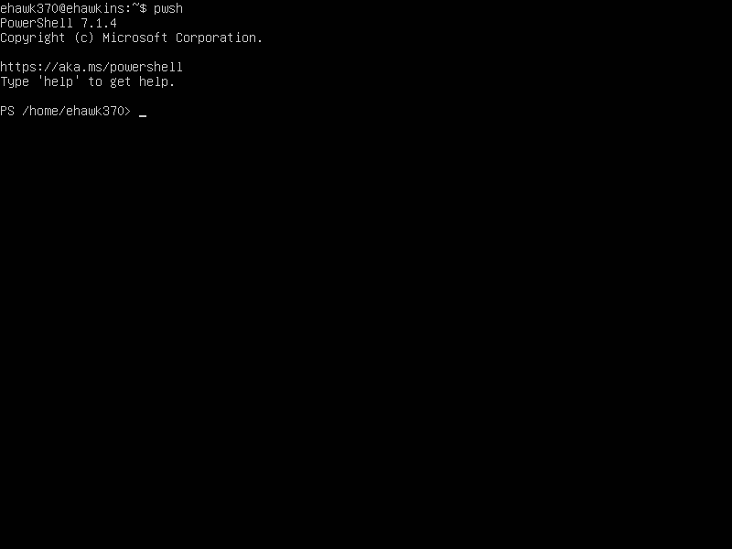

When it comes to any changes in the software or changes in configurations, I just updated the software and I installed net-tools.

